1. **Config AdventuresWorks Database in SQL Database**
2. Open Microsoft SQL Server Management Studio 18.
3. Specify the Server name as localhost\SQLEXPRESS and Authentication as Windows Authentication, click Connect.

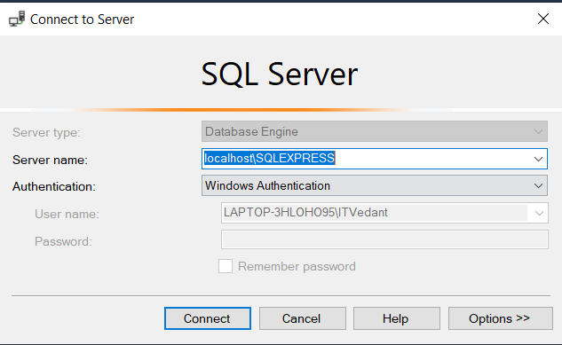

1. From Object Explorer, right-click on the Database folder and select Restore Database.

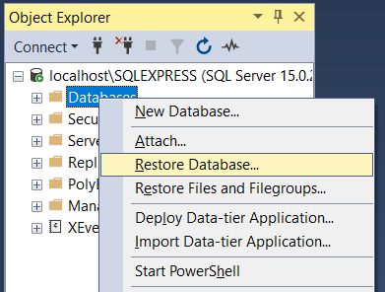

1. Select Device Radio-button and select … button adjacent to it.

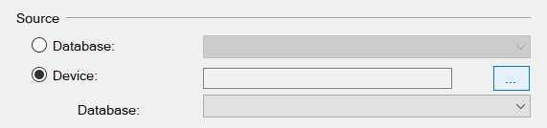

1. Click Add.

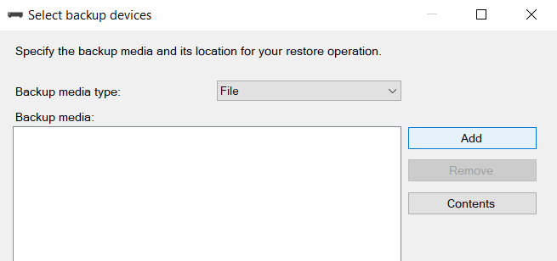

1. Traverse to folder where AdventureWorksDW2019.bak is stored and select it, Click OK.

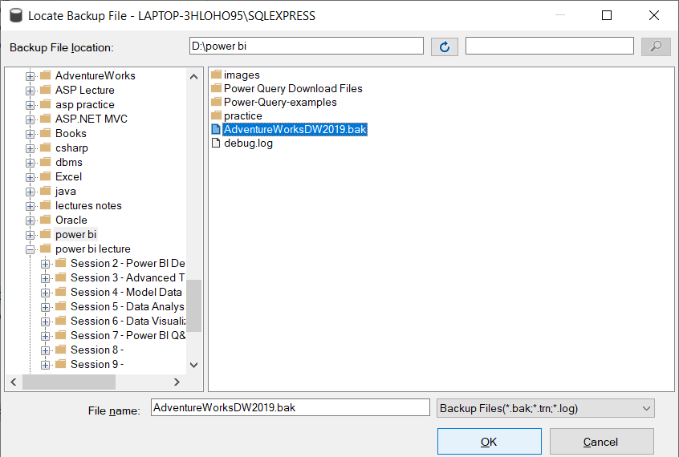

1. Click OK.

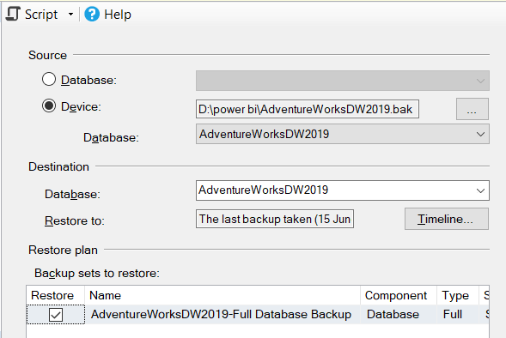

1. Click OK.
2. Should get the following dialog box and database will be reflected in the database folder of the object explorer.

